Advancing Food Security in Fragile Contexts: Joint Monitoring Report FY25-26 review
Over the last year, the World Bank’s Preparedness Plans for Food and Nutrition Security Crises programme convened 13 national training workshops across four regions, bringing together governments, international organisation and civil society to strengthen countries’ ability to detect, monitor and respond to food and nutrition crises before they escalate.

Highlights of the year
- The successful delivery of training workshops in Cameroon, Central African Republic, Chad, Ethiopia, Haiti, Liberia, Malawi, Niger, Nigeria, Sierra Leone and Sudan – the majority of these workshops were conducted in person with attendance from technical FNS experts, national statisticians, ministry officials, humanitarian and development partners. With an average of 30 participants per workshop, these events showed real cross-sector alignment, where governments and partners sat together, reviewed the evidence, and built shared understanding of when and how to act to food and nutrition security crises.
- The full operationalization in multiple countries, including Somalia, Yemen, and Cameroon, showcasing the evolving buy-in of governments and stakeholders to implement scalable high-frequency approach for food security monitoring and targeting of action.
- In-person cross-country knowledge exchange between the Somalia National Bureau of Statistics (SNBS) and the Sudan JMR risk team at the June 2026 workshop. Similar cross-country knowledge exchanged is now being discussed with partners in the ECOWAS region.
- Supporting Somalia's triggering of the Preparedness Plan in December 2025. The triggering of the plan resulted in the release of USD 50 million through the World Bank Crisis Response Window, to support social protection and health and nutrition interventions.
- Supporting government ownership, resilience building and the localisation agenda through holding technical deep-dive JMR risk model training sessions and leveraging the flexibility of the model to integrate national owned datasets such as country specific climate data.
- Global showcase of the JMR and high frequency risk monitoring at the Let’s Talk Data event in Geneva in March 2026 with a 100+ senior and technical stakeholders attending. The event was supported by the publication of an agriculture briefing.
- Continued technical engagement with external partners including IPC ATARI, Cadre Harmonisé, Google.org, the Rockefeller Foundation and the recently established International Data Community.
- The continuation of high frequency JMR monitoring in Yemen since December 2023 and Somalia since July 2024 showing how low cost, high frequency food and nutrition security monitoring can be established as an effective and sustainable model.

A few detailed insights from the multi-country engagements
- The JMR process provided a strong incentive for enhanced collaboration between governments and stakeholders (including humanitarian and development partners). Focal countries showed varying degrees of pre-existing interaction with other relevant partners in relation to monitoring or addressing food and nutrition security. By convening JMR workshops, governments showed more intentionality in inviting and engaging diverse stakeholders, while co-defining the mutual values for partnership on food security priorities during the workshops.

- Data systems, governance, and sustainability issues came to fore as a common challenge across countries. During the data discovery segments of the JMR workshop, there were high expectations across most countries that the JMR approach will steer agencies towards addressing data gaps on food insecurity indicators. Stakeholders noted that a shift towards authoritative, open, and consistently available data is a viable kick-start for frequent monitoring. Yet, they acknowledge that the JMR requires additional contextual data to enrich insights for JMR model outputs, relative to emerging needs and actions in-country. Such contextual data requires hands-on collaboration across the stakeholders, with clear commitment and structured systems that can enable seamless data exchange and integration for timely intelligence on food security status and outlook.

- Leading governmental institutions demonstrated varying preferences regarding the language and identified indicators of food and nutrition monitoring, and the need to be sensitive to such nuanced requirements in engagement. For example, most countries were comfortable with the general wording used in global contexts for severity or acuteness of food insecurity, while Ethiopia required major change (such as use “extreme food insecurity” instead of “acute food insecurity”. Also, in Chad Republic and Niger, stakeholders noted the high relevance of livestock-focused indicators, based on the dominance of pastoral agriculture in the region. This requirement guided further discussions among stakeholders regarding the structure and core elements of JMR reporting for the countries in alignment with the context. Future engagements and assessments can lean more into these country-specific requirements to foster responsive implementation and enhance traction with stakeholders.
Country | Date | Photos
Haiti | June 2026 (hybrid) | 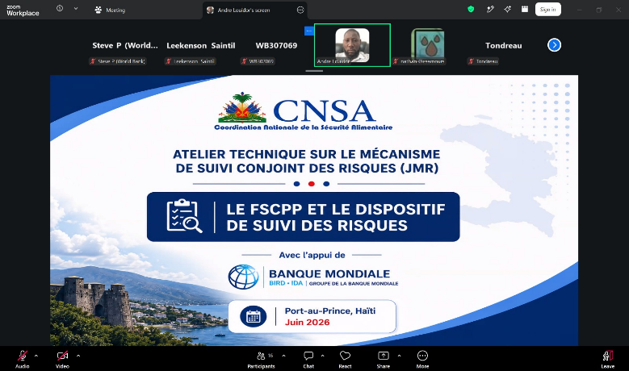
Sudan workshop 2 | June 2026 | 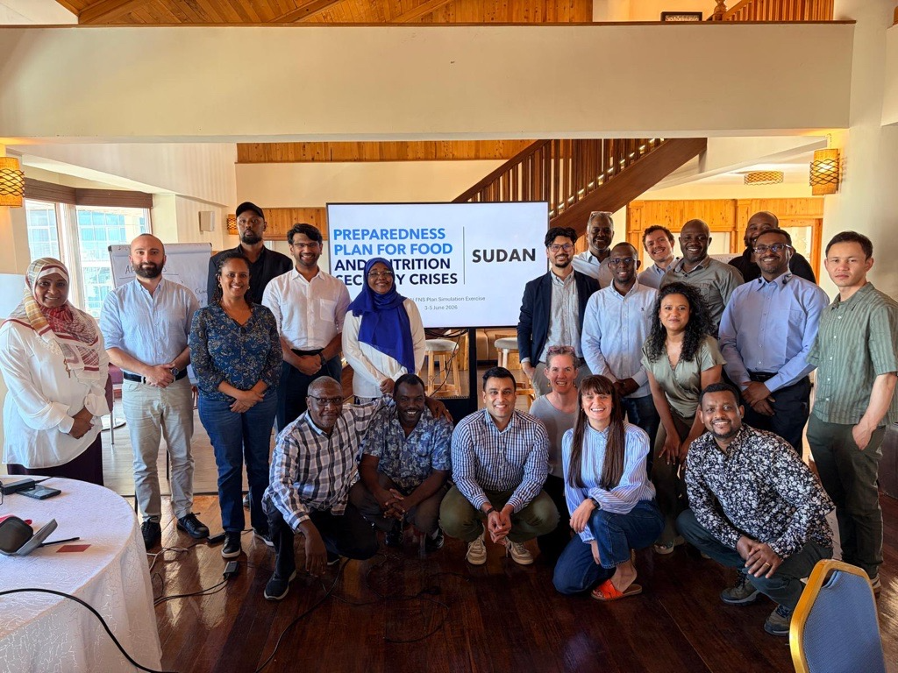  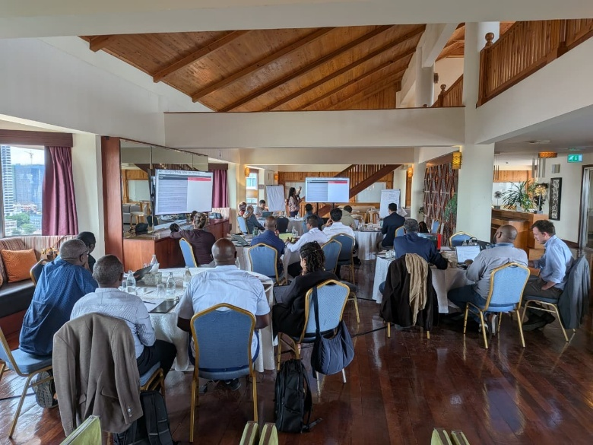  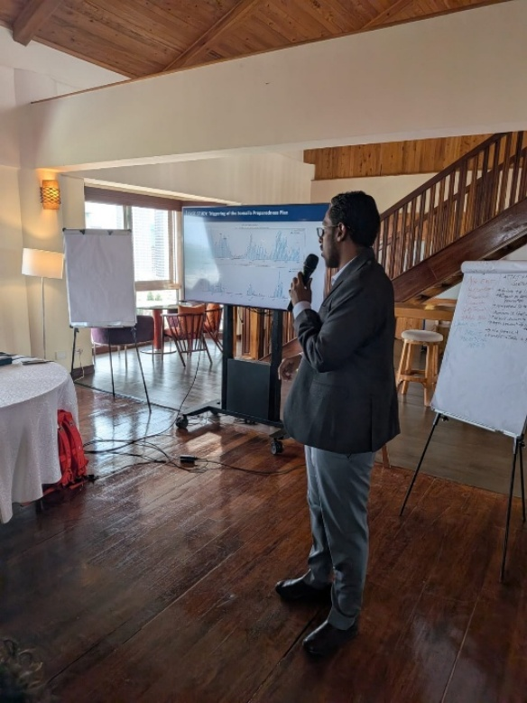
Sierra Leone | June 2026 | 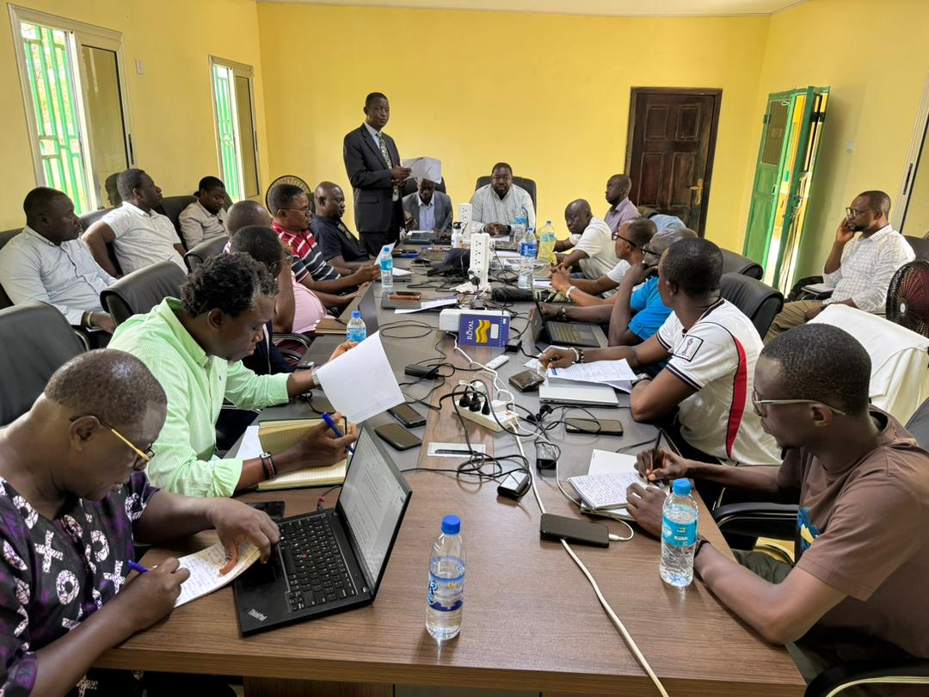
 |  | 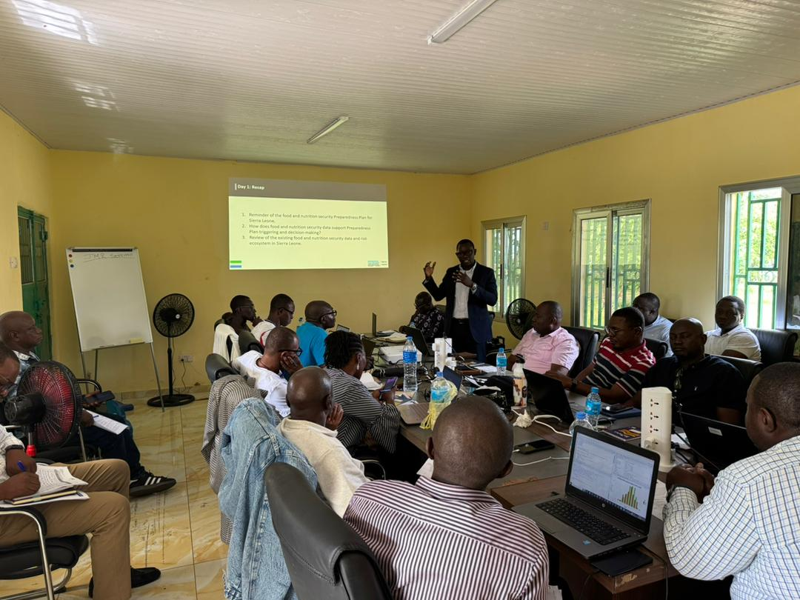
 |  | 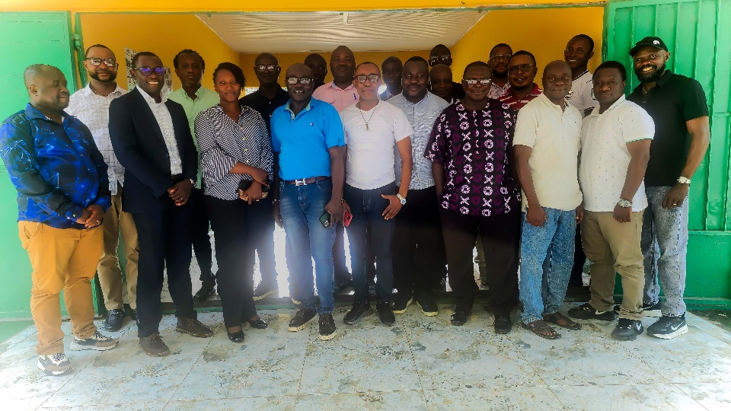
Liberia | June 2026 | 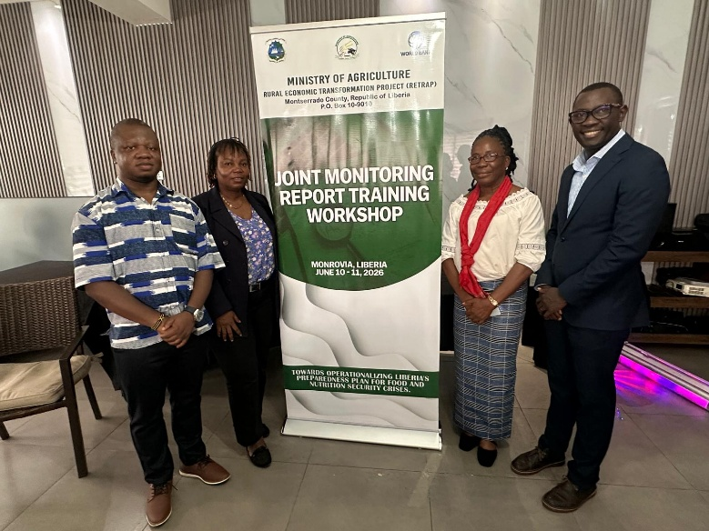
 |  | 
CAR | May 2026 | 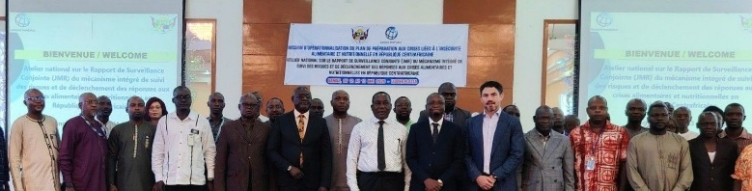  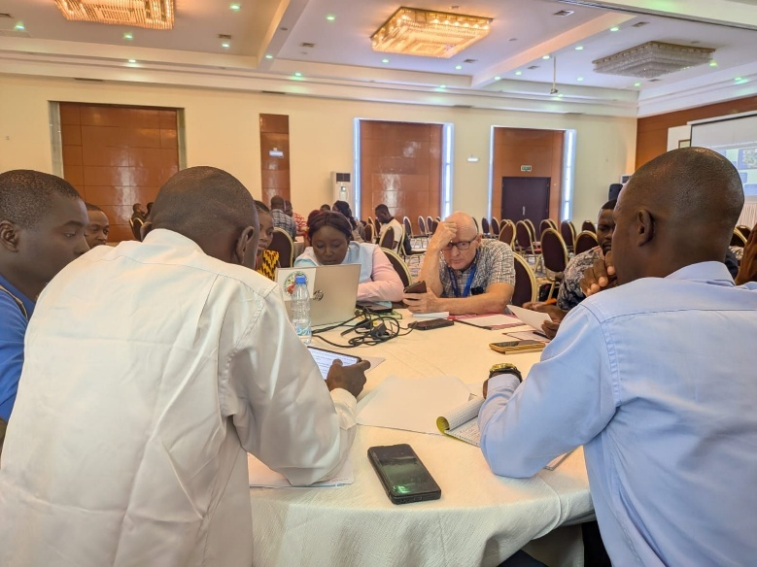  - Post from the Ministry of Agriculture and Rural Development
Niger | April 2026 | 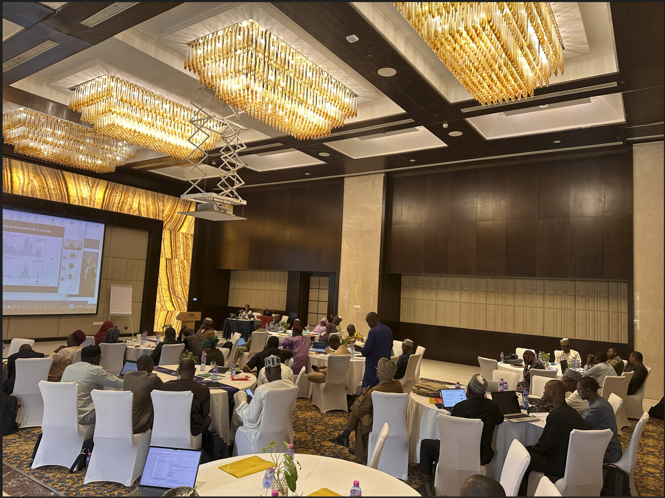
 |  | 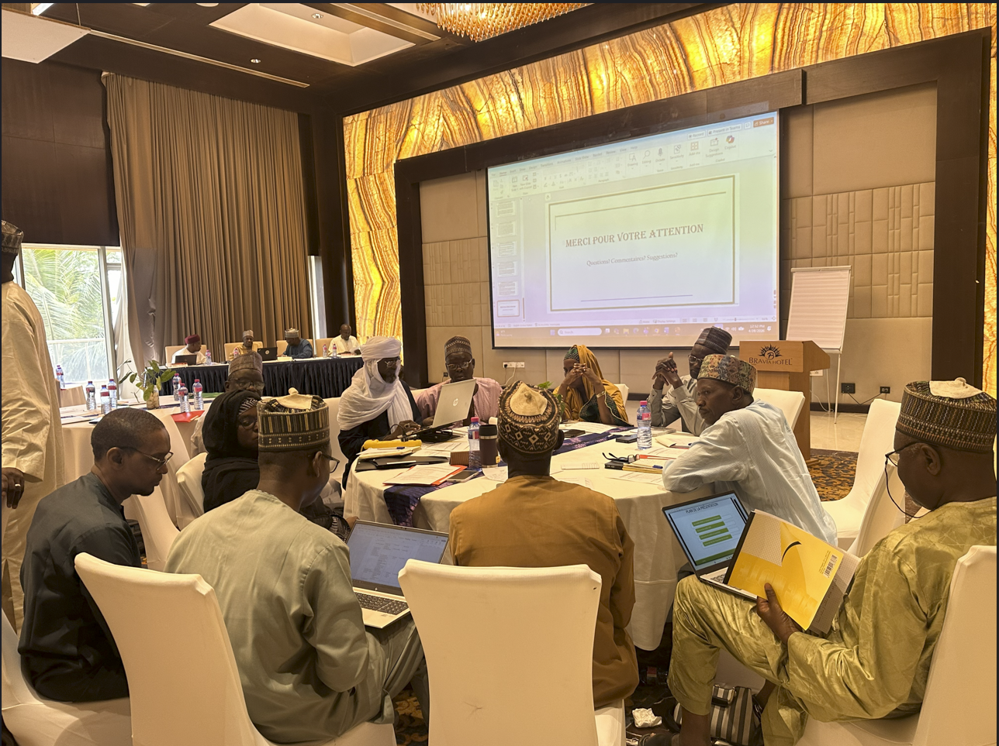
Chad | April 2026 | 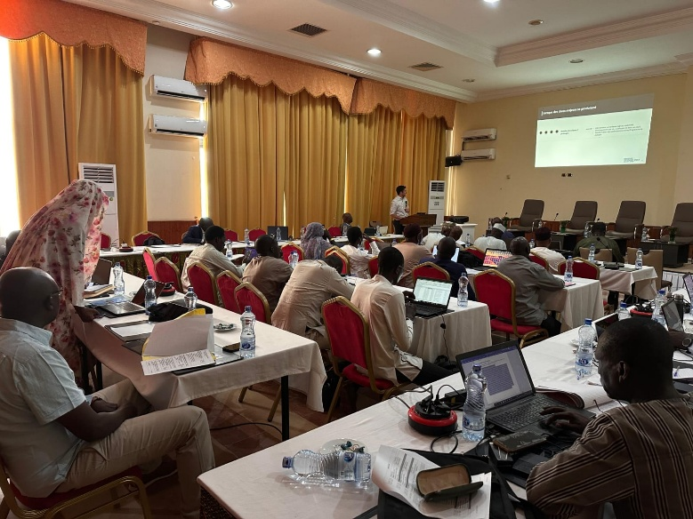
Ethiopia | March 2026 | 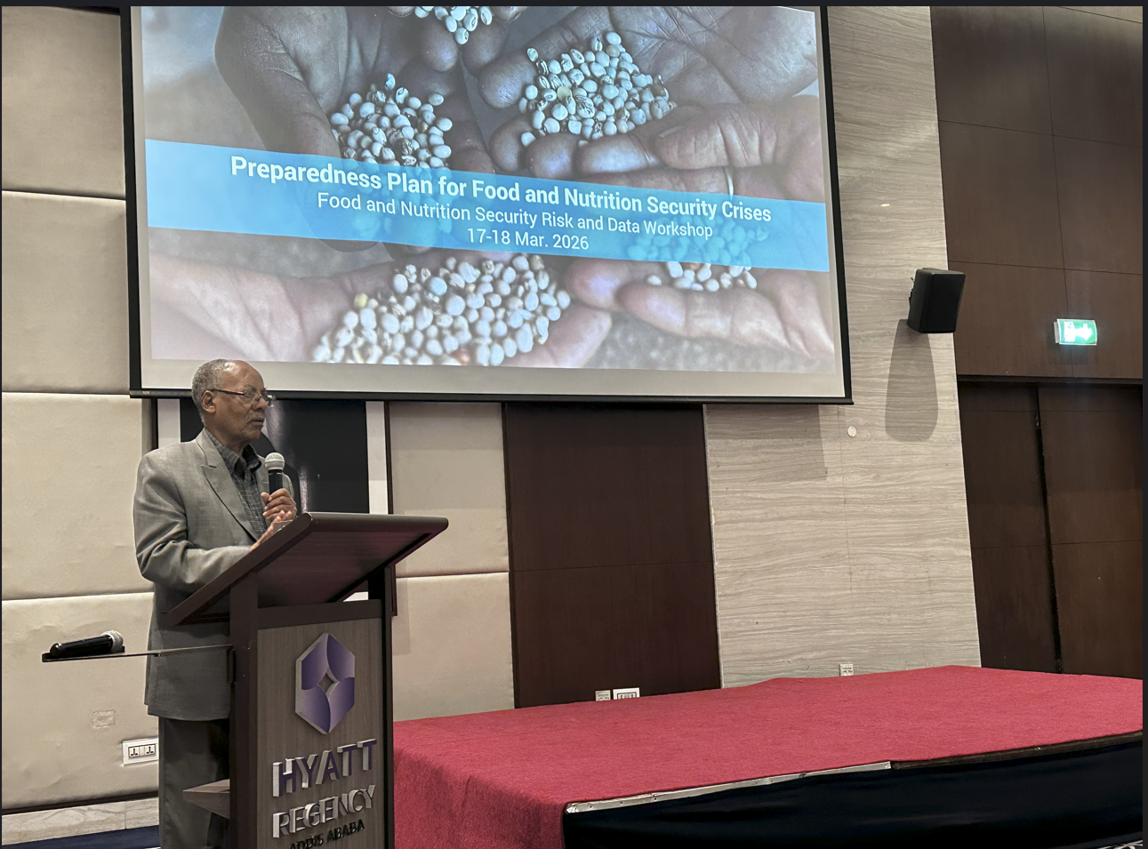
 |  | 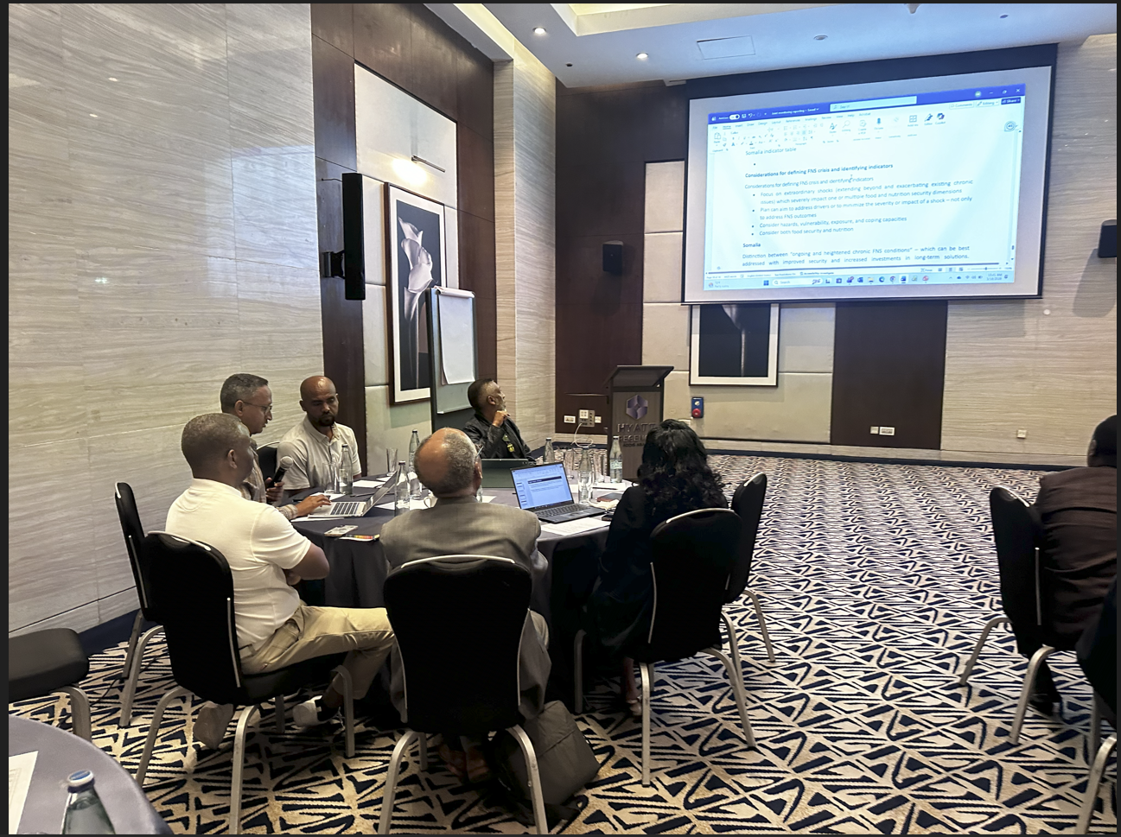
Malawi | March 2026 | 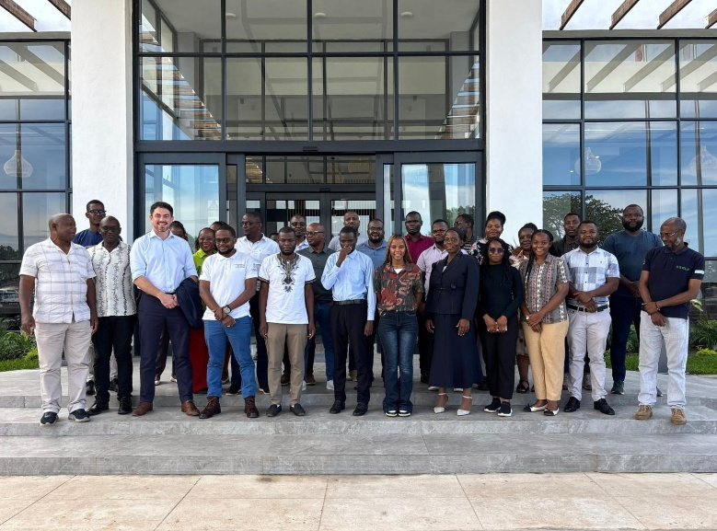  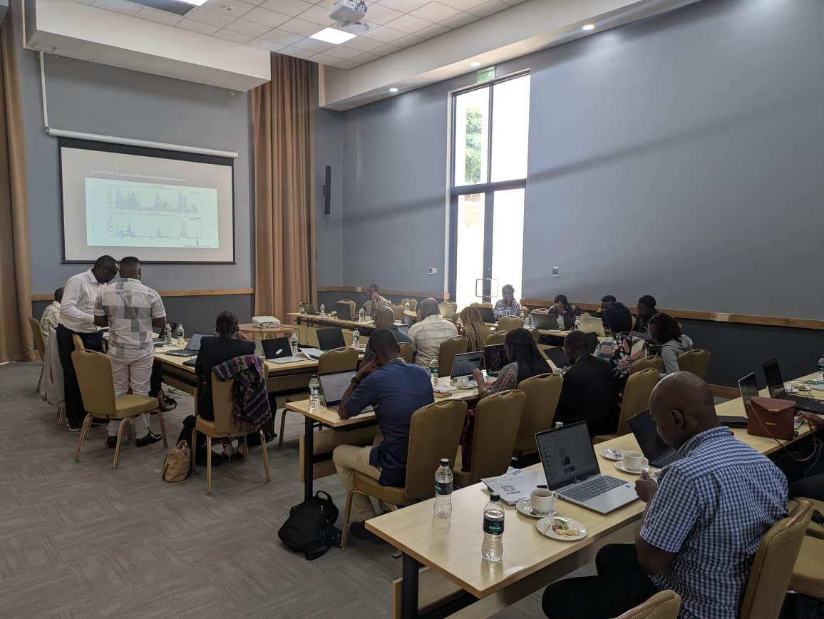
Cameroon | December 2025 | 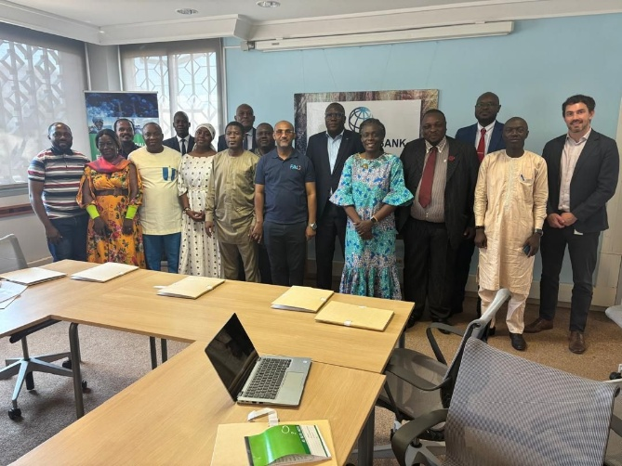
Sudan workshop 1 | November 2025 | 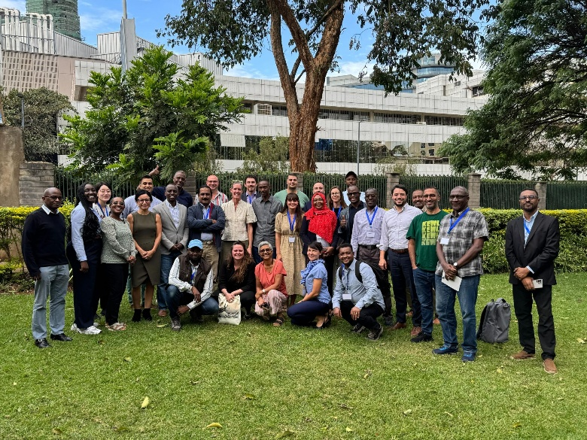  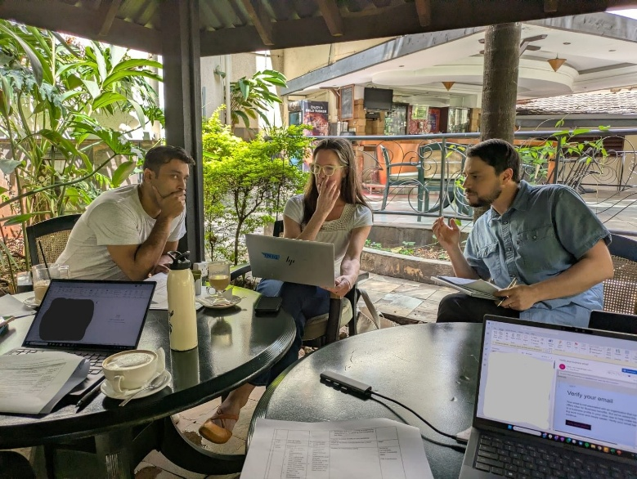
Nigeria | July 2025 | 